### Semester One Examination, 2021

### Question/Answer booklet

# MATHEMATICS SPECIALIST

**UNIT 3**

## Section Two:

## Calculator-assumed

|  |
| --- |
|  |

Your Name

Your Teacher’s Name

## Time allowed for this section

Reading time before commencing work: ten minutes

Working time: one hundred minutes

## Materials required/recommended for this section

***To be provided by the supervisor***

This Question/Answer booklet

Formula sheet (retained from Section One)

***To be provided by the candidate***

Standard items: pens (blue/black preferred), pencils (including coloured), sharpener, correction fluid/tape, eraser, ruler, highlighters

Special items: drawing instruments, templates, notes on two unfolded sheets of A4 paper, and up to three calculators approved for use in this examination

## Important note to candidates

No other items may be taken into the examination room. It is **your** responsibility to ensure that you do not have any unauthorised material. If you have any unauthorised material with you, hand it to the supervisor **before** reading any further.

|  |  |  |  |  |  |
| --- | --- | --- | --- | --- | --- |
| **Question** | **Marks** | **Max** | **Question** | **Marks** | **Max** |
| **9** |  |  | **16** |  |  |
| **10** |  |  | **17** |  |  |
| **11** |  |  | **18** |  |  |
| **12** |  |  | **19** |  |  |
| **13** |  |  | **20** |  |  |
| **14** |  |  | **21** |  |  |
| **15** |  |  |  |

**Structure of this paper**

|  |  |  |  |  |  |
| --- | --- | --- | --- | --- | --- |
| Section | Number of questions available | Number of questions to be answered | Working time (minutes) | Marks available | Percentage of examination |
| Section One:  Calculator-free | 8 | 8 | 50 | 49 | 34 |
| Section Two:  Calculator-assumed | 14 | 14 | 100 | 96 | 66 |
|  |  |  |  | **Total** | 100 |

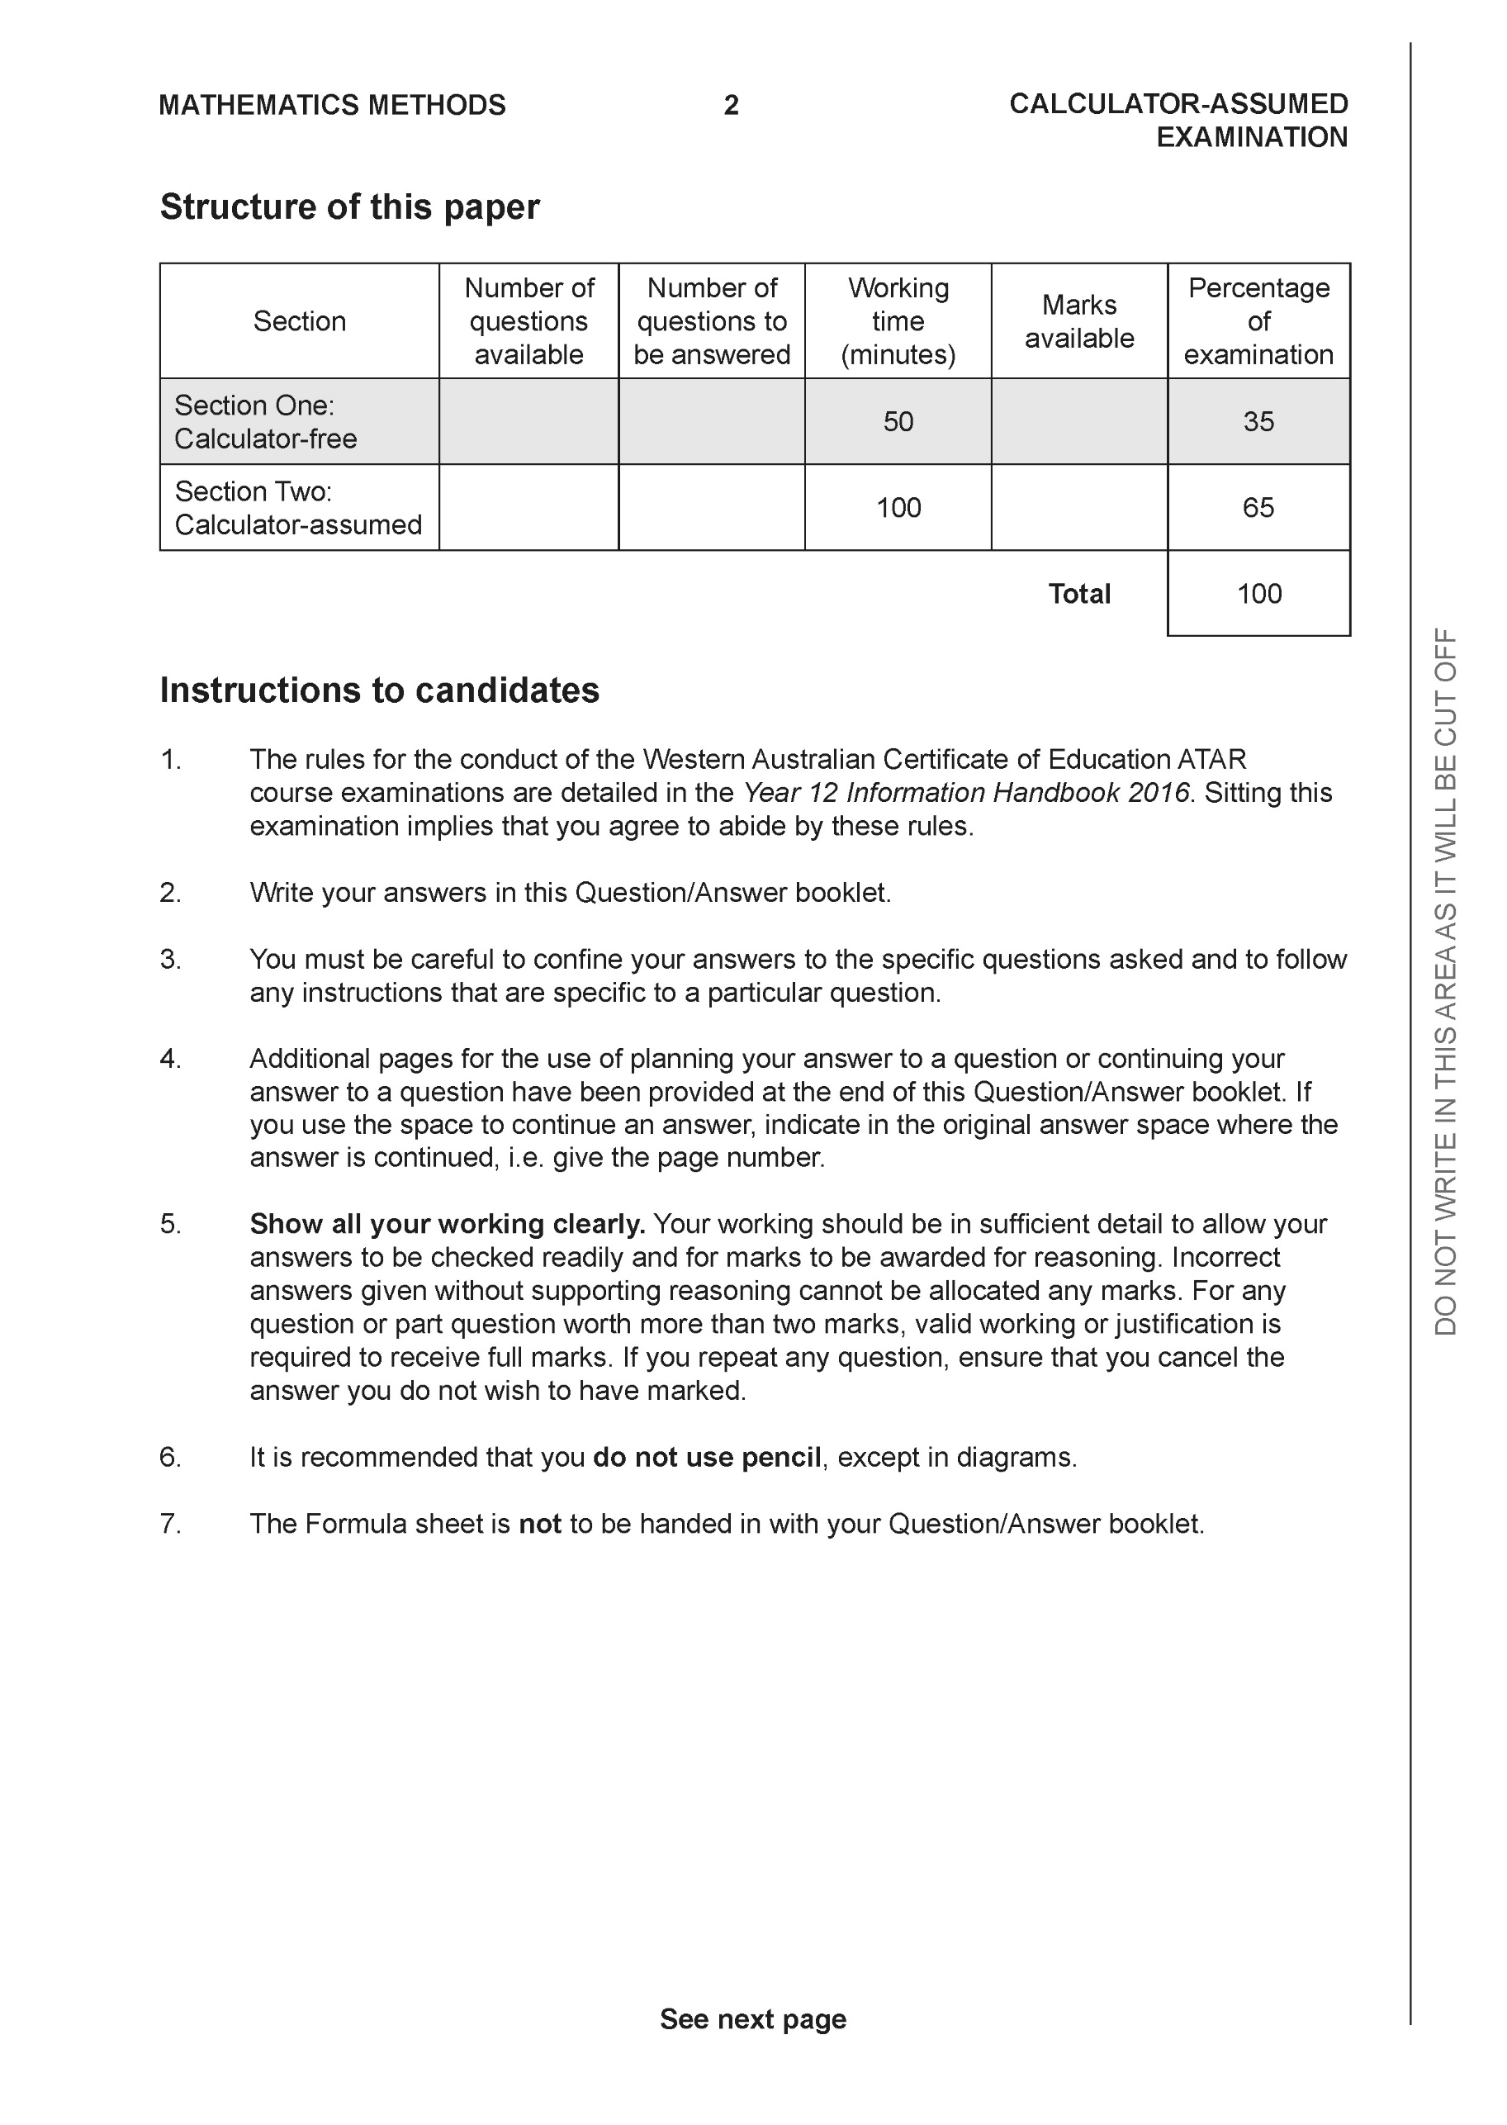

**Section Two: Calculator-assumed (96 Marks)**

This section has **14** questions. Answer **all** questions. Write your answers in the spaces provided.

Spare pages are included at the end of this booklet. They can be used for planning your responses and/or as additional space if required to continue an answer.

● Planning: If you use the spare pages for planning, indicate this clearly at the top of the page.

● Continuing an answer: If you need to use the space to continue an answer, indicate in the original answer space where the answer is continued, i.e. give the page number. Fill in the number of the question that you are continuing to answer at the top of the page.

Working time: 100 minutes.

**Question 9 (6 marks)**

1. Sketch the locus of the equation  on the axes below. (3 marks)

|  |
| --- |
| **Solution** |
|  |
| **Specific behaviours** |
| 🗸 refers to two points shown on graph  🗸 uses perpendicular bisector  🗸 shows locus |

1. Determine the cartesian equation of this locus in terms of . (3 marks)

|  |
| --- |
| **Solution** |
|  |
| **Specific behaviours** |
| 🗸 subs z=x+iy  🗸 squares both sides and expand real and imaginary terms  🗸 states cartesian equation, no need to simplify |

**Question 10 (9 marks)**

Consider the locus  as graphed below.

Determine the following.

1. Maximum value of . (2 marks)

|  |
| --- |
| 1. **Solution** |
|  |
| **Specific behaviours** |
| 🗸 uses modulus of centre  🗸 determines maximum |

1. Minimum value of  (3 marks)

|  |
| --- |
| **Solution** |
|  |
| **Specific behaviours** |
| 🗸 determines distance from (-8,12) to centre  🗸 subtracts radius  🗸 states approx. distance or exact |

1. Sketch the region defined by and on the axes above stating the coordinates of all boundary points. (4 marks)

|  |
| --- |
| **Solution** |
|  |
| **Specific behaviours** |
| 🗸 sketches line  🗸 shades above line and within circle to give required region  🗸 states approx. coords for one point  🗸 states approx. coords for two points |

**Question 11 (6 marks)**

Consider the line  and the point A.

1. Using **scalar dot** product show how to find the closest distance of point A to the line above.

(3 marks)

|  |
| --- |
| **Solution** |
|  |
| **Specific behaviours** |
| 🗸 obtains expression for displacement vector  🗸 uses dot product and equates to zero  🗸 determines magnitude, accept approx |

1. Using vector **cross** product show how to find the closest distance of point A to the line above.

(3 marks)

|  |
| --- |
| **Solution** |
|  |
| **Specific behaviours** |
| 🗸 shows that sine is needed  🗸 uses cross product with unit vector  🗸 determines magnitude of cross product |

**Question 12 (9 marks)**

Consider the sphere  with  being a positive constant and the line .

Determine all possible values of , (2 decimal places) for the following.

1. The line does not meet the sphere at all.
2. The line just touches the sphere at one point only.
3. The line meets the sphere at two points.

|  |
| --- |
| **Solution** |
|  |
| **Specific behaviours** |
| 🗸 subs line into sphere  🗸 states a vector equation for parameter and alpha  🗸 derives a quadratic equation for parameter in terms of alpha  🗸 derives an expression for discriminant  🗸 equates discriminant to zero  🗸 writes two inequalities for discriminant  🗸 states interval of values for no solution (discards negative values) and 2 dp  🗸states value for touching  🗸states values for meeting at two points  (max -1 if not 2 dp) |

**Question 13 (4 marks)**

Consider a prism where each side is a parallelogram with opposites sides congruent.

The units given are in metres.

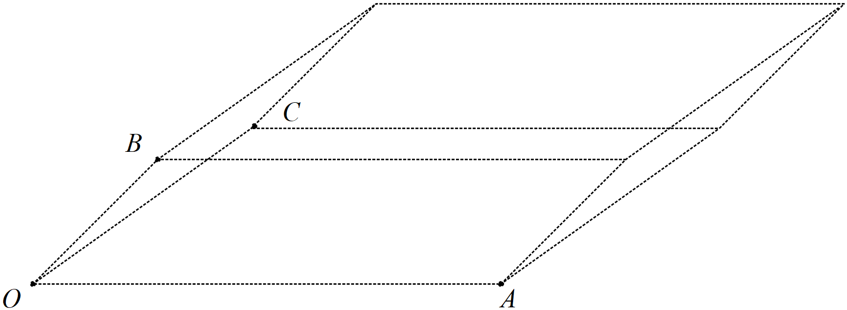

Given that  and **using vector** methods, determine the volume of the prism.

|  |
| --- |
| **Solution** |
| Volume = 259 cubic metres |
| **Specific behaviours** |
| 🗸 uses vectors in calculation  🗸 uses area of face in calculation OR cross product  🗸 uses perpendicular width OR dot product with normal of face  🗸 determines volume with units |

**Question 14 (9 marks)**

Consider the plane  .

1. Determine the distance of point A from the plane . (4 marks)

|  |
| --- |
| **Solution** |
|  |
| **Specific behaviours** |
| 🗸 determines any point on plane B OR vector equation of line  🗸 uses dot product  🗸 uses normal vector  🗸 determines approx. distance |

1. Determine an expression in terms of  for the distance of point P from the plane . (3 marks)

|  |
| --- |
| **Solution** |
|  |
| **Specific behaviours** |
| 🗸 uses a vector of pt P to any point on plane  🗸 uses dot product with unit normal  🗸 determines expression within absolute value |

1. If point Ais on a plane parallel to , determine a vector equation for this parallel plane. (2 marks)

|  |
| --- |
| **Solution** |
|  |
| **Specific behaviours** |
| 🗸 uses normal vector and dot product  🗸 states vector equation of plane |

**Question 15 (7 marks)**

Consider two submarines A & B moving in deep ocean with constant velocities  .

At 12:30am submarine A is at position  and at 1am the same day

submarine B is at position .

1. Determine the time, to nearest minute, that the submarines are closest to each other stating this distance to the nearest metre, (4 marks)

|  |
| --- |
| **Solution** |
| Let t=0 be at 1am |
| **Closest approach at 4:07am at 5198 metres**  **Specific behaviours** |
| 🗸 determines position of both subs at the same time  🗸 sets up equation to solve for time at closest approach (dot or calculus)  🗸 states time at closest approach to nearest minute  🗸 states distance rounded to nearest metre  (max -1 if not rounded) |

1. If both submarines leave a lasting water trail of bubbles, determine if the trails cross and if they do at which position under water. (3 marks)

|  |
| --- |
| **Solution** |
| Bubble paths meet at (38,2,10)km |
| **Specific behaviours** |
| 🗸 sets up equations with different parameters  🗸 shows that lines of bubbles do meet  🗸 states coordinates of such point |

**Question 16 (5 marks)**

Consider the complex numbers  such that:



Determine  in the form  where  are real numbers.

|  |
| --- |
| **Solution** |
|  |
| **Specific behaviours** |
| 🗸 determines Arg(p)  🗸 sets up equation for Arg(z) conjugate  🗸 determines modulus of p & w  🗸 determines Arg(z) & modulus of z  🗸 expresses z in cartesian form |

**Question 17 (11 marks)**

Consider the 3D object  as drawn below with  the origin and 

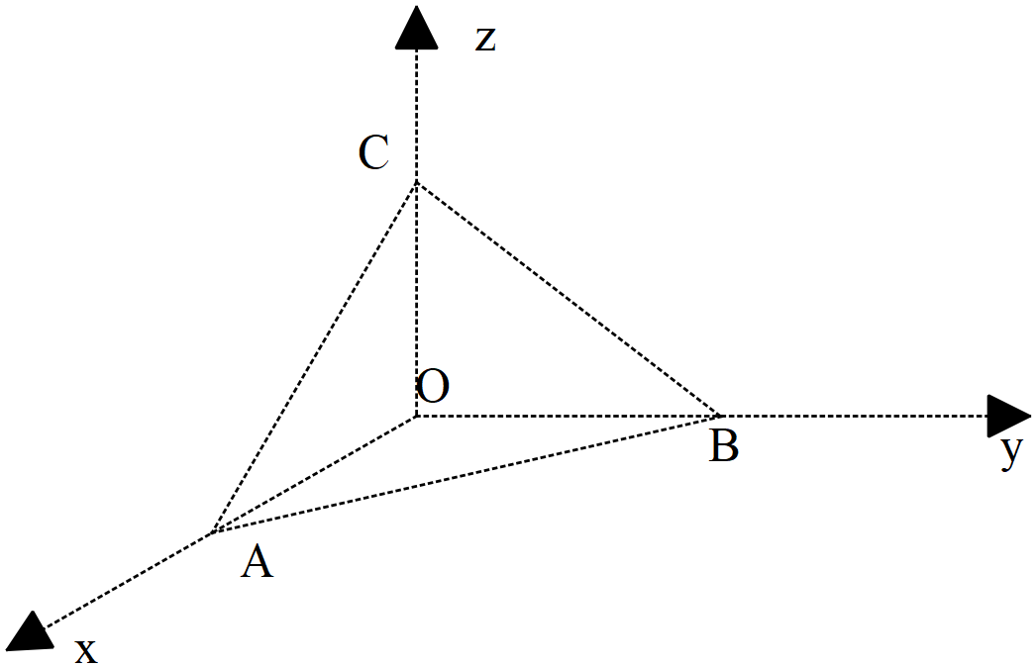

1. Determine the vectors . (2 marks)

|  |
| --- |
| **Solution** |
|  |
| **Specific behaviours** |
| 🗸 determines vector AB  🗸 determines vector AC |

1. Determine to the nearest degree the angle  (2 marks)

|  |
| --- |
| **Solution** |
|  |
| **Specific behaviours** |
| 🗸 uses dot product  🗸 determines angle in degrees or radians(no need to round) |

1. Determine the exact area of triangle using vectors. (3 marks)

|  |
| --- |
| **Solution** |
|  |
| **Specific behaviours** |
| 🗸 uses cross product  🗸 determined an expression for area  🗸 determined exact area |

1. Determine the cartesian equation of the plane containing triangle . (4 marks)

|  |
| --- |
| **Solution** |
|  |
| **Specific behaviours** |
| 🗸 determines normal vector  🗸 sets up equation for vector equation  🗸 determines vector equation  🗸 determines cartesian equation |

**Question 18 (7 marks)**

Consider the vectors 

1. Determine  given that  are parallel**, ** is perpendicular to  and  is perpendicular to **.** (4 marks)

|  |
| --- |
| **Solution** |
|  |
| **Specific behaviours** |
| 🗸 uses scalar multiple between a & b vectors  🗸 uses dot product equally zero for perpendicular  🗸 solves for one unknown  🗸 solves for all unknowns |

1. Given that , determine a vector parallel to  but equal in magnitude to .

(3 marks

|  |
| --- |
| **Solution** |
|  |
| **Specific behaviours** |
| 🗸 determines magnitude of a & e vectors  🗸 determines unit vector parallel to a  🗸 determines final vector (plus or minus) |

**Question 19 (7 marks)**

1. Consider the cartesian equation . Describe what this locus of points represents and state major features and give the **vector** equation.

(4 marks)

|  |
| --- |
| **Solution** |
| Sphere with centre (3,-4,1.5) with radius root29/2 |
| **Specific behaviours** |
| 🗸 completes the square for each variable  🗸 states vector equation  🗸 states a sphere with radius stated  🗸 exact radius stated |

1. Consider the equation  where  is a constant. Determine the values of  for which the equation would be a sphere giving the centre and radius in terms of . (3 marks)

|  |
| --- |
| **Solution** |
|  |
| **Specific behaviours** |
| 🗸 completes the square and states centre  🗸 all possible values of alpha (accept -14)  🗸 states general rule for radius |

**Question 20 (6 marks)**

Let  be a complex number such that  and  .

1. Express in terms of  the complex number  . (simplify) (3 marks)

|  |
| --- |
| **Solution** |
|  |
| **Specific behaviours** |
| 🗸 converts all number in polar form  🗸 simplifies modulus of total  🗸 simplifies argument of total |

1. Express  in terms of . (3 marks)

|  |
| --- |
| **Solution** |
|  |
| **Specific behaviours** |
| 🗸 shows diagram of addition with labels  🗸 recognizes isosceles triangle  🗸 derives correct expression |

**Question 21 (4 marks)**

Consider the polynomial  where  are real constants.

Given that  and  determine the values of .

|  |
| --- |
| **Solution** |
| a=13, b=-13, c=36 & d=-36 |
| **Specific behaviours** |
| 🗸 shows that z=1 I a root  🗸 uses conjugates of complex roots in factorising  🗸 expresses polynomial as a product of factors  🗸 determines values of all unknowns |

**Question 22 (6 marks)**

1. Using De Moivre’s theorem, derive an expression for  in terms of  only.

(3 marks)

|  |
| --- |
| **Solution** |
|  |
| **Specific behaviours** |
| 🗸 shows that expression is derived from real part of De Moivre’s use  🗸expands expression of cubic  🗸expresses all terms in cosine form |

1. **Using** the result from (a) above, show how to obtain **all** solutions to  in the form . Express possible values of  in **exact** form.

(3 marks)

|  |
| --- |
| **Solution** |
|  |
| **Specific behaviours** |
| 🗸 expresses equation using result from cos3x  🗸solves for three possible exact values of angle. NOTE- many other values possible  🗸expresses all solutions in exact cosine form.  NOTE- decimal values or surd expressions from classpad will not be accepted for any marks |